Butter and Influencers Quotes:
Becoming a chef takes a considerable time commitment, it consumes you night and day. Long weekends, holidays and family gatherings. Missing important weddings, birthdays and gatherings. Normal life was squeezed between double shifts or other creative scheduling. As an infant my daughter was propped up on a prep table, while I butchered fish in the early pre service hours. My wife endured countless home alone nights due to extended travels or late closings. Bless her!
Sporting events were difficult to follow as games were played on weekends, there was no chance to stay current with player’s names, wins and playoff series. I did however, stay up to date on fellow chefs and who was cooking where, what and how. My esteemed colleagues, became the focus of our culinary conversations. While working in New York and New England, I was honored to learn from many great chefs and cooks. Here is some background on the most influencing of those.
Fernand Point:
“Butter! Give me Butter! Always Butter!
Chef Point‘s book “Ma Gastronom”, made a huge impression on me as a young cook, in my early twenties. The stories he tells, and simple elegant recipes from his “Le Pyramid” restaurant, gave me an understanding of how to approach my culinary adventures. He broke from “Haute Cuisine”, traditions, by using only the freshest ingredients available each day, starting at point zero in his larder and “méson plaice”. In the 1940’s-50’s, the three Michelin starred temple to grand cuisine, became the breeding ground for young chefs to embark toward the evolution of Nouvelle Cuisine as it bloomed in the early seventies. I had the opportunity to work under one of his disciples Chef Michael Shannon on Nantucket. One of Chef Point’s battle cries was “Butter, Butter, give me everywhere!
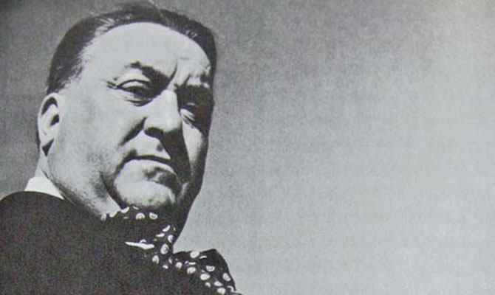

Roger Verge:
Chef Verge, My Mentor. Chef Verge changed my life. I worked in his restaurant, Moulin des Mougins, a three starred Michelin treasure, in Mougins France over several years. He was a culinary pioneer, in the mid-seventies, he was the first French Chef to influence the regional local cuisine movement. He used classic technique with ingredients from the Cote de Azur, in the South of France. Local olive oils, butters and cheeses accompanied regional seafood, vegetables and meats. Farmers, Foragers and Fishermen would knock at the kitchen door each morning offering wares for the evening menu. This approach to indigenous cooking was quickly adopted in Europe and the America’s for its simple yet elegant panache. The experience was my master’s degree in Culinary Arts, sixteen hour workdays, tedious tasks, and blistered scarred hands, a labor of love and I loved it. Yes, there was Butter, lots of it!
“A cook is creative, marrying ingredients in the way a poet marries words”
“A recipe is not meant to be followed exactly- it is a canvas on which you embroider”
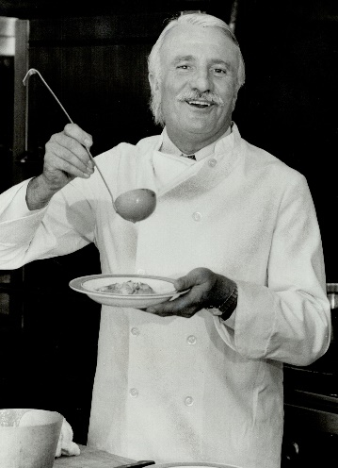
Paul Bocuse :
A living legend in gastronomy, countless accolades and honors bestowed on him and a global inspiration for every chef of our generation. Chef Bocuse was a close friend of Verge’, they were business partners and shared the same approach to culinary philosophy. Fresh ingredients, respect for the classics, and a passion to share the art with others. His Cuisine de Lyonnaise, embraces the use of many compound butters, butter sauces and finishing butters. Throughout my career I have had the honor to enjoy his table, cook for him and work with him. He is a forceful presence in and out of the kitchen. A strict task master, yet fatherly and not beyond the role of a prankster.
“Without Butter, without eggs there is no reason to come to France”
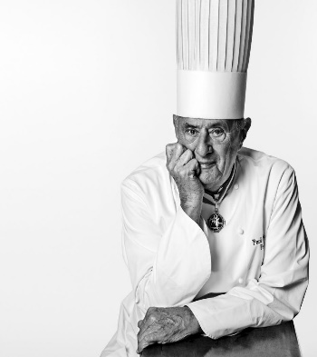

Julia Childs:
Growing up in Boston, I was exposed to Julia very early. My Mum would have her on TV’s PBS Channel 2, when I returned home from school, we smiled at her bantering’s and marveled at her techniques. I was always intrigued by her high pitched voice and what she was dramatically preparing. I had started in restaurants as a pot washer and was a prep cook by fourteen, triggering a deep respect for the ways of the stove, so I took to watching her too. Years later, I ended up meeting and cooking for her, we cooked together for charities, and culinary foundations. She was larger than life, the Queen of American Gastronomy. She had a love of laughter, a love of food, and a love of butter “everything in moderation” .
“With enough butter everything is good”
“You are the butter to my bread the breath to my life”
“Everything in Moderation including moderation”
“Giving up butter means you will be covered in dandruff in two years!”
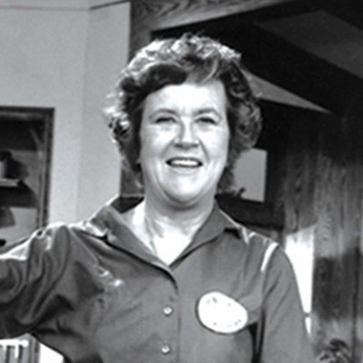
Escoffier:
Augustus Escoffier
All chefs today must understand the classics in order to understand the origins of their craft. At the turn of the twentieth century, Chef Escoffier, born in 1846, had risen to become the, “Chef to Kings and King of Chefs”. Not only was he a Master Chef, but he set the standards to which all modern kitchens still run today. He organized the hierarchy and responsibilities of each “brigade”. He wrote le Guide de Culinaire, a comprehensive organization of classical haute cooking. This cook book– encyclopedia is still used today, over a hundred years later, to reference dishes, recipes, techniques and protocol. He worked for royalty in the grand era of noble splendor. He started the Ritz with partner Caesar Ritz in Paris, as well as the Savoy and Carlton in London. He elevated the lowly task of scullery cooking to a skilled craft and art form. His influence on gastronomy include compound butters. He re-created, Bruere Montpelier, Maître Butter, Colbert Butter, Ravigote, Bercy, and Raifort Butters. All hundred year old recipes, but just as delicious today
“Good Food is the foundation of genuine happiness”
